8th Grade Science Benchmark Assessment Key
(2014 – 2015)

Characteristics and Interactions of Living Organisms

1. III.2.C.a What’s the correct course of nutrients from the digestive to the circulatory system?
a) mouth -> stomach -> esophagus -> small intestine -> large intestine -> blood stream
b) mouth -> esophagus -> stomach -> small intestine -> blood stream -> cells
c) mouth -> esophagus -> stomach -> blood stream -> small intestine -> cells
d) mouth -> esophagus -> small intestine -> cells -> stomach -> bloodstream

2.III.2.C.e The muscles of the body are part of the musculoskeletal system but would not operate without the ____system providing the impulses that cause the muscles to act.
` a) nervous
b) cardiovascular
c) reproductive
d) respiratory

3. III.3.A.b Which is not an example of asexual reproduction?
a) budding b) regeneration c) fertilization d) binary fission

4. III.3.A.c Which of the following statements is NOT true about fertilization?
a) Most amphibians, birds, and reptiles practice internal fertilization
b) Most terrestrial animals practice internal fertilization
c) Many terrestrial males have an organ for sperm transfer.
d) Most aquatic animals practice external fertilization, releasing gametes into water

Interactions of Organisms With Their Environment

5. IV.3.C.a There are many kinds of warblers throughout the world. One kind of warbler with black and white feathers is often seen on tree trunks. Another kind with golden-colored feathers is often seen in fields. Which statement best explains how the color of these warblers helps them survive?
a.) The color of the feathers helps the birds locate nests.
b.)The color of the feathers helps to control the amount of body heat the birds lose.
c.) The color of the feathers blends into the birds’ surroundings and helps the birds avoid predators
d.) The color of the feathers attracts the kinds of insects the birds like to eat.

Processes and Interactions of the Earth’s Systems

6. V.1.A.a. Which of the following is not important for soil to support a good crop?
a) a pH near neutral
b) a good supply of water
c) a good supply of nutrients
d) a uniform particle size

7. V.1.B.a Which is NOT a characteristic of water that makes it essential for life?
a) Ability to act as a solvent
b) Ability to remain as a liquid at most Earth temperatures.
c) Ability to act as a solute
d) Ability to maintain cohesion (surface tension).

8. V.1.C.b What role does the atmosphere play in our lives and the weather we experience? a) Precipitation, retains the Moon's heat, reflects and filters light from the Sun,
traps heat energy transmitted from the Earth's surface.
b) Precipitation, retains the Earth's heat, reflects and filters light from the Sun,
traps heat energy transmitted from the Earth's surface.
c) Precipitation, retains the Sun's heat, reflects and filters light from the Sun,
traps heat energy transmitted from the Earth's surface.
d) Precipitation, retains meteorites, reflects and filters light from the Sun, traps
heat energy transmitted from the Earth's surface

9. V.2.B.d Which process is building the Himalayas, the tallest mountains on Earth?
a) plates are moving apart
b) plates are colliding
c) plates are sliding past each other
d) Soil is building up due to erosion

10. V.2.D.c What do scientists measure when determining the absolute age of a rock?
a) amount of radioactivity
b) ratio parent and daughter isotopes
c) ratio of neutrons and electrons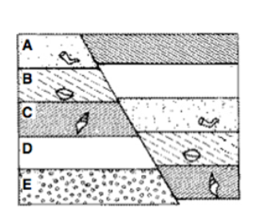
d) number of uranium atoms

11. V.2.D.d Which rock layer on the diagram is the oldest?
a) layer A b) layer B
c) layer D d) layer E

12. V.2.E.a What is the correct term for rising water vapor meeting colder air and turning back into water droplets?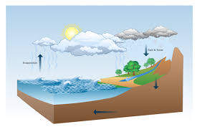
a) condensation
b) dehydration
c) precipitation
d) evaporation

13. V.2.F.a. In a small refrigerator, the ice-box is suspended from the top so that
a)warm air from the rest of the refrigerator will rise to the ice-box.
b)cold air from the rest of the refrigerator will rise to the ice-box.
c)cold air from the ice-box will sink to rest of the refrigerator.
d)warm air from the ice-box will sink to the rest of the refrigerator

14. V.2.F.c The weather behind a cold front is dominated by a
a)falling, relatively warm air mass
b) rising, relatively warm air mass
c) falling, relatively cold air mass
d)rising, relatively cold air mass

15. V.2.F.g The difference between weather and climate is _______________.
a) weather is a local phenomenon, climate is regional
b) weather is a day-to-day phenomenon, climate is a long-term average
c) weather is the non-scientific term for climate
d) there is no difference between the two

16. V.2.F.h What happens to the intensity of solar energy as latitude increases?
a) It stays the same.
b) It increases.
c) It decreases.
d) It doubles.

17. V.3.A.e The water that was around when dinosaurs roamed the Earth:
a) Is gone, and has been for a long time.
b) Is about halfway gone.
c) Is the same water we use today.
d) Would be really dirty if it were still around.

18. VI.1.A.a Listed below are the minimal qualifications established by the International Astronomical Union for a planet:
· I. Orbits the sun.
· II. Shape "rounded-out" by gravity.
· III. Cleared/dominates orbit around sun.

Which of these qualifications are met by an asteroid?
a) I only.
b) Both I and II.
c) Both I and III.
d) (None of the above choices.)

19. VI.1.A.c Which object is closest to Earth?
a) Sun
b) Mercury
c) Moon
d) Venus

20. VI.1.B.a A new solar system has been discovered, which of the objects below would be the
best for us to attempt to colonize
a) Object A produces its own light. All other objects in the solar system orbit around it. It appears to be made of hydrogen and helium.
b) Object B is irregularly shaped made of ice and rock. It has no atmosphere and temperatures range from -500ºC to 0ºC.
c) Object C is a spherical gaseous object that orbits around its sun. It has a solid core of iron, and it has an atmosphere of methane and nitrogen. The object has rings and numerous satellites orbiting it. Its temperatures range from 200 ºC to -450ºC.
d) Object D is hard and rocky. It orbits its sun. It has water on its surface. The atmosphere consists of Nitrogen, Carbon Dioxide, Oxygen, water vapor. The temperatures range from -10ºC to 60ºC.

21. VI.2.A.a What does Earth's rotation cause?
a) day and night
b) the seasons
c) eclipses
d) a year
21. VI.2.A.a What causes the apparent movement of objects across the sky during a day or night on Earth?
a) revolution of Earth in its orbit
b) rotation of Earth on its axis
c) location of Earth in space
d) objects are moving around Earth
22. VI.2.B.d In a famous album, ‘Pink Floyd’ referred to the ‘Dark Side of the Moon.’ This is:
a) meaningless, because every part of the moon is regularly lit up by the sun at some stage in its monthly orbit
b) meaningful, because the moon has one side which never receives any sunlight
c) unclear, because they may have meant the far side of the moon which we
only see after the passage of many centuries (since the moon rotates so very slowly)
d) meaningless, because the Earth precesses as it spins. The result is that we actually wind up seeing the Moon from every imaginable angle – top, sides, and bottom

23. VI.2.C.d Our solar system is shown below, which planet would have the longest year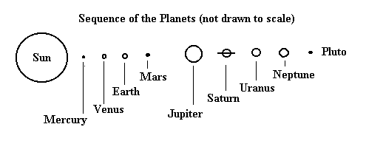
a) Mercury
b) Earth
c) Jupiter
d) Neptune

24. VI.2.C.e What phase of the moon would you see on this night?
a) half moon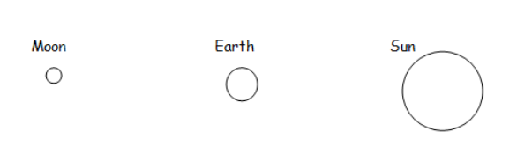
b) gibbous moon
c) new moon
d) full moon

25. VI.2.C.f Earth has seasons because
a) it rotates on its axis.
b) the distance between Earth and the sun changes.
c) its axis is tilted as it moves around the sun.
d) the temperature of the sun changes.

26. VI.2.D.b Name the fundamental force which holds the planets in their orbits around the sun.
a) Gravitational force of attraction
b) Electrostatic static force of attraction
c) Nuclear force of attraction
d) Magnetic force of the Earth’s core
27. VIII.1.A.a Technology often results from tools, processes and devices being developed and invented as part of a problem solving process. Which of the following is not an example of technology?
a) Velcro closures for clothes
b) Cars
c) Uranium
d) Xerox machines

28. VIII.1.B.a Galileo was able to demonstrate that the Earth (and other planets) rotated around the sun as a result of a development in technology. Which was it?
a) Development of X-ray photography.
b) Development of the telescope.
c) Invention of the guillotine.
d) Development of the microscope.

29. VIII.1.C.a Which of the following is not a major source of groundwater contamination?
a) agricultural products
b) landfills
c) septic tanks
d) all of the above are major sources of groundwater contamination

30. VIII.2.A.a Which continent has not contributed to scientific knowledge?
a) Africa
b) South America
c) Asia
d) Antarctica

31. VIII.3.B.a One of the best solutions to get rid of non-biodegradable wastes is
a) burning
b) dumping
c) recycling
d) burying

Finding Out About Frogs
Latrice’s class wanted to learn more about frogs so they decided to study Bull Frogs. Only five students hunted for tadpoles. Denise found 3 tadpoles, Marquis found 6 tadpoles, Jordan found 11 tadpoles, Emily found 5 tadpoles and Danisha found 8 tadpoles.

32. VII.1.D.a Construct a data table in the space below comparing the students with the number of tadpoles found. Be sure to label column correctly
· Accurate Title for table 1pt
· All Columns labeled correctly 1pt
· Rows labeled correctly 1pt
Students and Tadpoles
Student | Number of Tadpoles
Denise | 3
Marquis | 6
Jordan | 11
Emily | 5
Danisha | 8

33. VII.1.D.a Use the data from the data table you created to construct a bar graph. Be sure to provide
· An appropriate title (ex. Students and Tadpoles) 1pt
· A label for each axis with appropriate units. X- Students y- Number of Tadpoles Caught 1pt
· An appropriate number scale and category labels y- count by ones 0-12 x – student’s names 1pt
· Correctly plotted data bars correct for each student 1pt

Another class decided to monitor the growth rate of western gray tree frog tadpoles, over 5 days. They fed the tadpoles different amounts of food: Three had 1mg of lettuce, Three had 4mg of lettuce, and the last three had 6mg of lettuce each day at the beginning of class. They measured the length of each tadpole in centimeters each day at the end of class.

34. VII.1.A.b What is the independent variable? (1pt) __Amount of Food in mg_________

35. VII.1.A.b What is the dependent variable? (1 pt) _Growth: Length in cm _

36. VII.1.A.a Write a hypothesis for their investigation (1pt)__States the independent and dependent variable. Predicts how the independent variable will affect the independent variable.

37. VII.1.B.d List two tools they will need to test the hypothesis about frogs. (2pt)
Metric ruler or measuring tape, clock, calendar, beaker, or other measurement tool to measure amount of food.

In the data table below is the average daily growth for each of the tadpoles over the 5 days:

Table 1: Amount of Food vs Growth in cm per day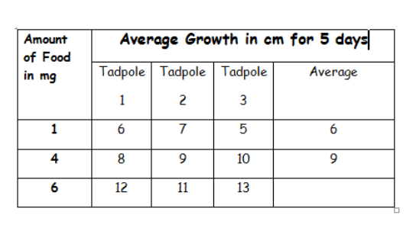

38. VII.1.B.g Calculate the average/mean of the growth in cm for the tadpoles fed 6mg of lettuce. Show your work______________ (2pt)
12 + 11 + 13 = 36 36/3= 12

39. VII.1.D.a Use the data from the table to construct a line graph on the grid. Graph only the averages growth for each amount of food. Be sure to provide:
- Appropriate title (1pt) Amount of Food vs. Growth in cm (example)
- Label each axis with appropriate categories (1pt) X-axis: Amount of food (mg) & Y-axis: Growth (cm)
- Appropriate interval or categories (1pt) Example: Y-axis 0,1,2, 3, 4, & X-axis 0, 1, 2, 3, …
- Data correctly plotted (1pt) Connected with a line, including 0

40. VII.1.C.a What conclusion can you make about the amount of food fed to tadpoles from the data?
a) As amount of food decreases, growth increases.
b) As amount of food increases, growth decreases
c) As amount of food increases, growth increases
d) There is no general trend or pattern between temperature and wing flapping.

41. VII.1.C.b Predict what will happen if you fed the tadpoles 2mg of lettuce each day?
a) The tadpoles will have an average growth of 6 cm.
b) The tadpoles will have an average growth of 7 cm.
c) The tadpoles will have no growth.
d) There is not enough data to make a prediction.

